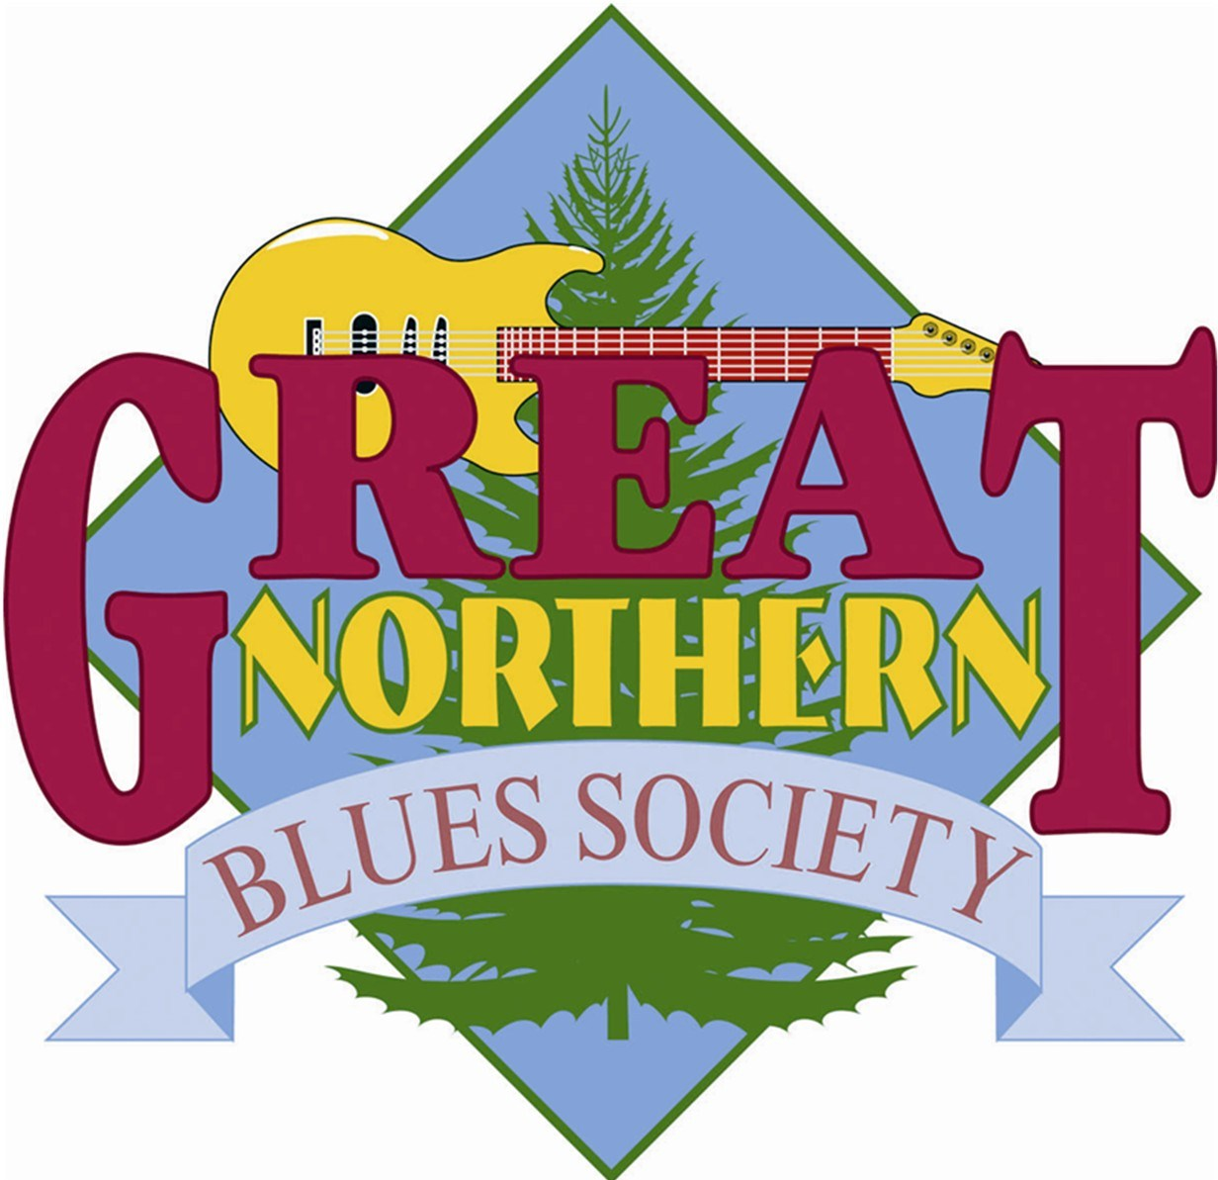
Free ‘Blues in the Schools’ event slated for March 8 @ UWMC

The Great Northern Blues Society (GNBS) is pleased to announce that they are, once again, sponsoring an extended Blues in The Schools (BITS) event featuring the Norman Jackson Band from Missouri. They will be coming to the Wausau Area to perform live on Glen Moberg’s “Route 51” Public Radio Program on Thursday, March 8 from 10:00 to 11:00 AM with a short period to answer questions after the show.
"Route 51" can be heard on AM 930 WLBL Auburndale/Stevens Point, 91.9 WLBL Wausau, 90.3 WHBM Park Falls, 89.9 WHSF Rhinelander/Eagle River, and 89.1 WHAA Adams/Wisconsin Rapids Thursdays at 10:00 AM. It is also repeated Fridays at 7:00 PM on 90.9 WHRM Wausau.
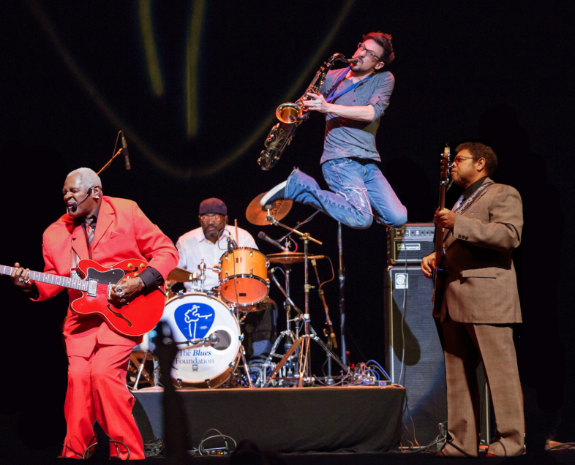
Ranked third in the world at the 2016 International Blues Challenge Finals, “The Soul Machine” Norman Jackson and his groove-inducing, love-producing band guarantees that when they play the blues you will “get your happy on!” Norman is the genuine article, growing up on the south side of Chicago, he was taught the blues from the true giants in blues and soul. Norman began to apprentice his saxophonist, Rick Shortt from the age of 12, who is now the turbine engine of the band, playing lead on saxophone. Along with the rock-steady rhythm section of Danny Williams and “The Boogie Man,” the “baddest soul band in the land” will take you on a journey with stories from their lives on a road filled with laughter and showmanship laced with virtuoso mastery that will make everyone “get down and get happy.”
The band enjoyed a banner year in 2016, playing blues festivals around the United States and is already booked in 2018 to play major festivals and showcases from New York to New Mexico along with Europe and Israel. Their new record, “It’s the Drummers Fault,” was released in May worldwide.
This event is absolutely free to the public, and once again, will take place at 10:00 AM on March 8 in the James F. Veninga Theater on the UWMC Campus at 518 S. 7th Avenue, Wausau, WI.
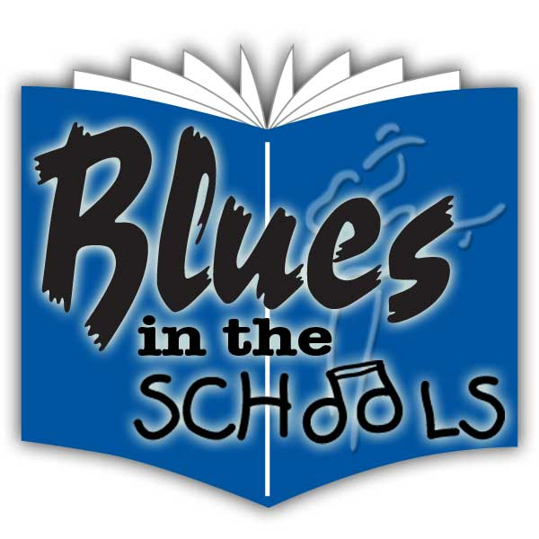
Norman and his Band will also be performing at the Blues Café at the Rothschild Pavilion on March 10, where they will be playing in the 3:00 PM time slot, and will also be playing at the Intermission Bar in downtown Wausau after the Café concludes.
For more information or to purchase tickets to the society’s 19th Annual Blues Café, visit their website at www.gnbs.org.

