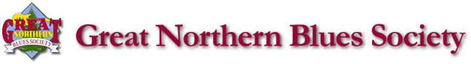

To our friends of the Wausau area,
Because next year’s Blues Café is our “Lucky 21st” edition, we are offering all corporate sponsors double the normal number of tickets to the show. What does that mean? Well basically, you get almost all of your money back in the value of the tickets. For example, Silver level corporate sponsors will receive eight free tickets to the show ($30 ea. value at the door = $240), etc. There is NO BETTER TIME to become one of our valued corporate sponsors!
We have put together spectacular shows over the past several years, and this year will be no different. We are bringing in the 2019 saxophone player of the year – Vanessa Collier; a nominee for the 2017 B.B. King Entertainer of the year – John Nemeth; and six-time BMA Nominee as guitar player of the year – Ana Popovic who Bruce Springsteen described as “one helluva guitar player.” These acts, along with four other bands will undoubtedly light up the stage at the Rothschild Pavilion March 13 & 14, 2020. Tickets to this show would make great gifts to customers and/or employees. PLEASE consider being a GNBS corporate sponsor for 2020 as your help is critical to our success.
 | Bronze | Silver | Gold | 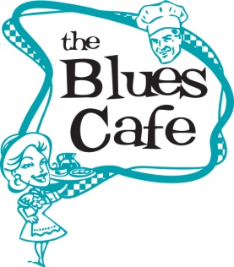  Platinum
Contribution | $100 | $250 | $500 | $1000
Tickets to Blues Café | 4 | 8 | 16 | 32
Logo/Sponsor mention in print ads | Name | Logo | Logo | Logo
Logo/Sponsor mention in radio ads | No | Yes | Yes | Yes
Logo/Name Added to GNBS Website | Logo | Logo | Logo | Logo
Logo/Name added to video display screens  at Blues Café between main stage acts | Yes | Yes | Yes | Yes
Your membership helps bring great shows to the Wausau area, including the Blues Café, Blues in the Schools, scholarships for area high school students, and much, much more.
If you can once again honor us with your corporate sponsorship, please send a check made payable to the Great Northern Blues Society by December 17, so we can be sure to add your logo to our website, posters, and video display for the Pavilion during the show. Or to sign up online, please visit our sponsorship posting at midwestblues.org/membership
Thank you in advance for any consideration that you may be able to provide.
Mike Tatro
GNBS President
WWW.GNBS.ORG ∙ P.O. box 2276 ∙ Wausau, WI 54402 ∙ GNBS@GNBS.org

